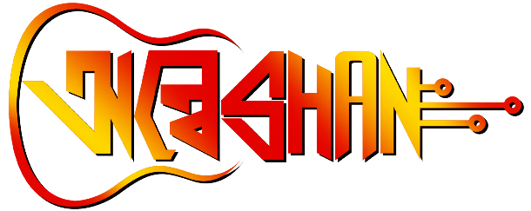

**NRITYANATYA**

**Description:**

Get ready to groove and showcase your rhythmic talent at our university's upcoming tech and cultural fest! Introducing "Nrityonatya," a thrilling dance competition that celebrates the fusion of technology and culture. Step onto the stage with your team and mesmerize the audience with your coordinated moves, creativity, and passion for dance. Whether you're an expert in contemporary, classical, or fusion styles, this event welcomes all forms of dance. Join us for a captivating evening filled with music, energy, and artistic expression. Let's dance to the beats of innovation and tradition at Nrityonatya!

Guidelines

**Rules & Regulations:**

NRITYANATYO is a form of Indian classical dance that combines elements of both pure dance (Nritya) and dramatic storytelling (Natya). When presenting a NRITYANATYO, a traditional Indian dance form, it is important to follow certain rules and guidelines to ensure a respectful and authentic performance. Here are some general rules to consider:

* Eligibility: Participation in Nrityanatya is open to groups or dance troupes who specialize in Indian classical dance forms. A group should have at least 3 to 5 members.
* Time Limit: Maximum duration of presenting Nrityanatya is 10 minutes (minimum 5 minutes).
* Music: Participants must provide their own music for the performance in an acceptable audio format (CD, USB etc. ). Live musical accompaniment such as traditional instruments or vocals is allowed, but must be arranged and coordinated by the participants.
* Costumes and Props: Wear appropriate costumes that are specific to the style of Nrityanatya you are performing. each team should bring their own props.
* Stage Presence: Engage with the audience through eye contact, facial expression and interactive gestures whenever appropriate. Convey the essence and emotions of the Nrityonatya to the audience, creating a connection and a captivating experience.

All the participants are requested to abide by these rules otherwise it may result in disqualification from the NRITYANTYO COMPETITION. For further clarification please contact to the event organizers.

We appreciate your involvement and eagerly anticipate your participation!

PLEASE NOTE: A Registration Fee of ₹100 per team member has to be Paid.